**1. Initial Data Segregation**

- Parse rest JSONs separately

- Calculate baseline metrics from rest phase using 800-sample windows

- Key metrics to track:

- MNF/ARV ratio

- IMA differences

- EMD values

- Fluctuation metrics

**2. Baseline Characterization**

- Cross-session analysis of rest phases

- Establish normal variation ranges

- Identify potential drift patterns

- Define statistical thresholds for "true" idle state

**3. Calibration Assessment**

- Compare rest phase metrics between sessions

- Test hypotheses:

H1: Baseline varies significantly between sessions

H2: Drift occurs within sessions

H3: Environmental factors affect baseline

**4. Decision Criteria Development**

- Define threshold violations

- Establish minimum calibration duration

- Create trigger conditions for recalibration

**Metrics to keep track:**

* + **Percentile 80:**
    - Why It's Useful: Helps define a threshold that separates most of the data (80%) from potential outliers (spikes). This threshold can serve as a benchmark for acceptable muscle activity in the resting phase.
    - Application: Identify participants with unusually high resting muscle activity or data anomalies due to spikes.
  + **Percent Below 80th:**
    - Why It's Useful: Provides a check on the data's distribution and verifies if the majority (e.g., 80%) of the values conform to the threshold set by the percentile 80. This helps ensure that most data fits within expected bounds, especially after normalizing for variability across participants.
    - Application: Compare distributions between participants to detect deviations.
  + **Mean and Standard Deviation (mean +- std):**
    - Why They're Useful: The mean gives a central tendency for each metric, while the std quantifies variability. Together, they help determine if baseline muscle activity is consistent across individuals.
    - Application: Highlight participants with higher variability, indicating potential instability in rest sEMG.
  + **Range (max - min):**
    - Why It's Useful: Indicates the spread of the data. A large range in rest sEMG metrics could signal irregularities, including spikes or sudden jumps.
    - Application: Investigate whether a large range correlates with poor baseline stability.

Analysing the rest phase, values are very different in each participant. When it comes to RMS, then the values tend to be more similar.

|  |  |  |  |  |
| --- | --- | --- | --- | --- |
| Participant | Session | Phase | RMS_min | RMS_max |
| Alexia | Session1 | Phase A (Rest) | 1.25 | 1.5 |
| egw | Session1 | Phase A (Rest) | 1.3 | 1.4 |
| marios | Session1 | Phase A (Rest) | 1.5 | 1.8 |
| mitsos | Session1 | Phase A (Rest) | 3 | 15 |
| nektarios | Session1 | Phase A (Rest) | 1.3 | 1.35 |
| next | Session1 | Phase A (Rest) | 1.3 | 2.3 |
| next2 | Session1 | Phase A (Rest) | 1.1 | 1.2 |
| next3 | Session1 | Phase A (Rest) | 1.1 | 1.3 |
| vasilis | Session1 | Phase A (Rest) | 1.5 | 1.6 |



metrics(active)_dia_mean(metrics(rest))_marios_ID1

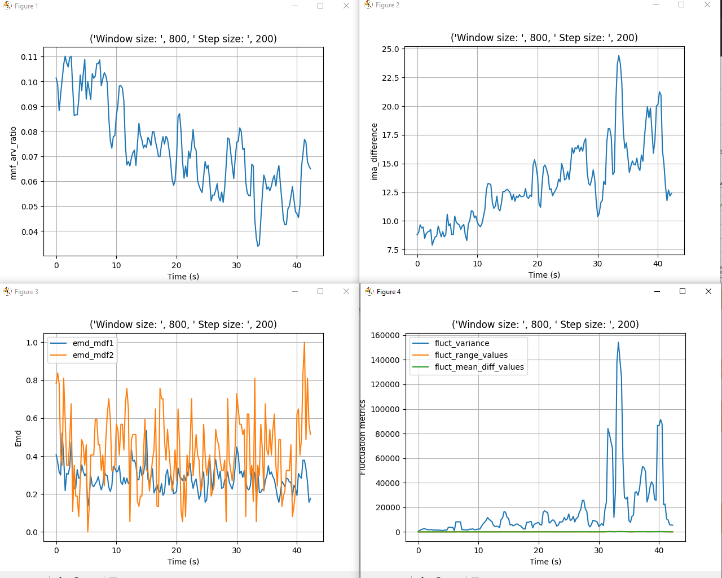

metrics(active)_dia_mean(metrics(rest))_next2_ID2

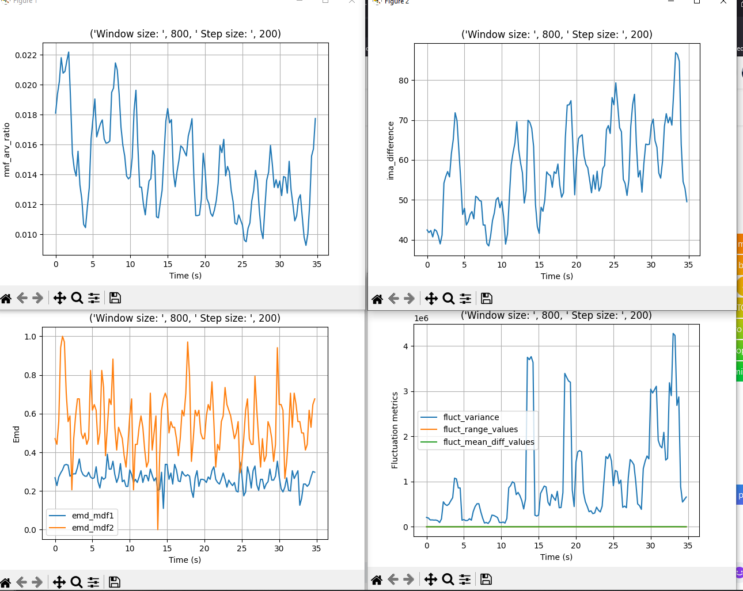

metrics(active)_dia_mean(metrics(rest))_mitsos_ID2

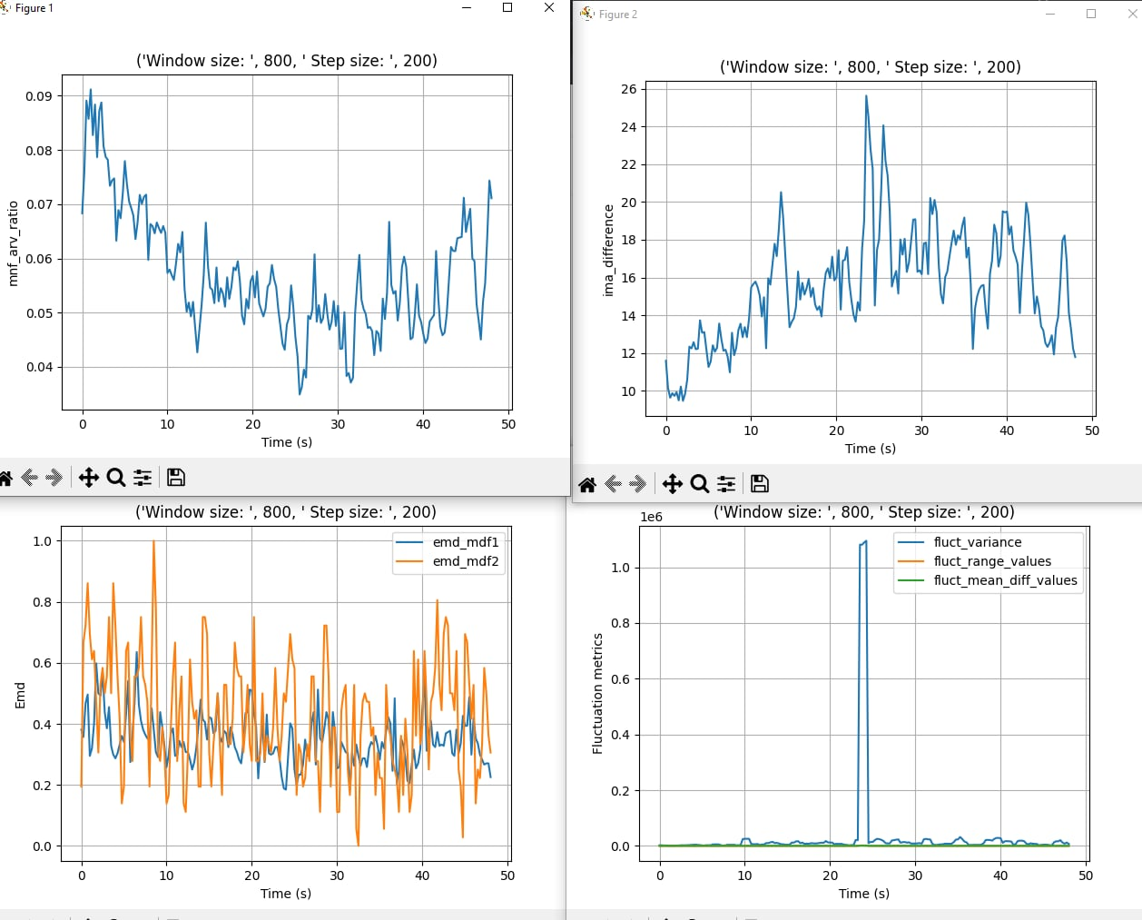



signal = active/active_first where active_first the rms of the first window   
  
active_marios_ID1

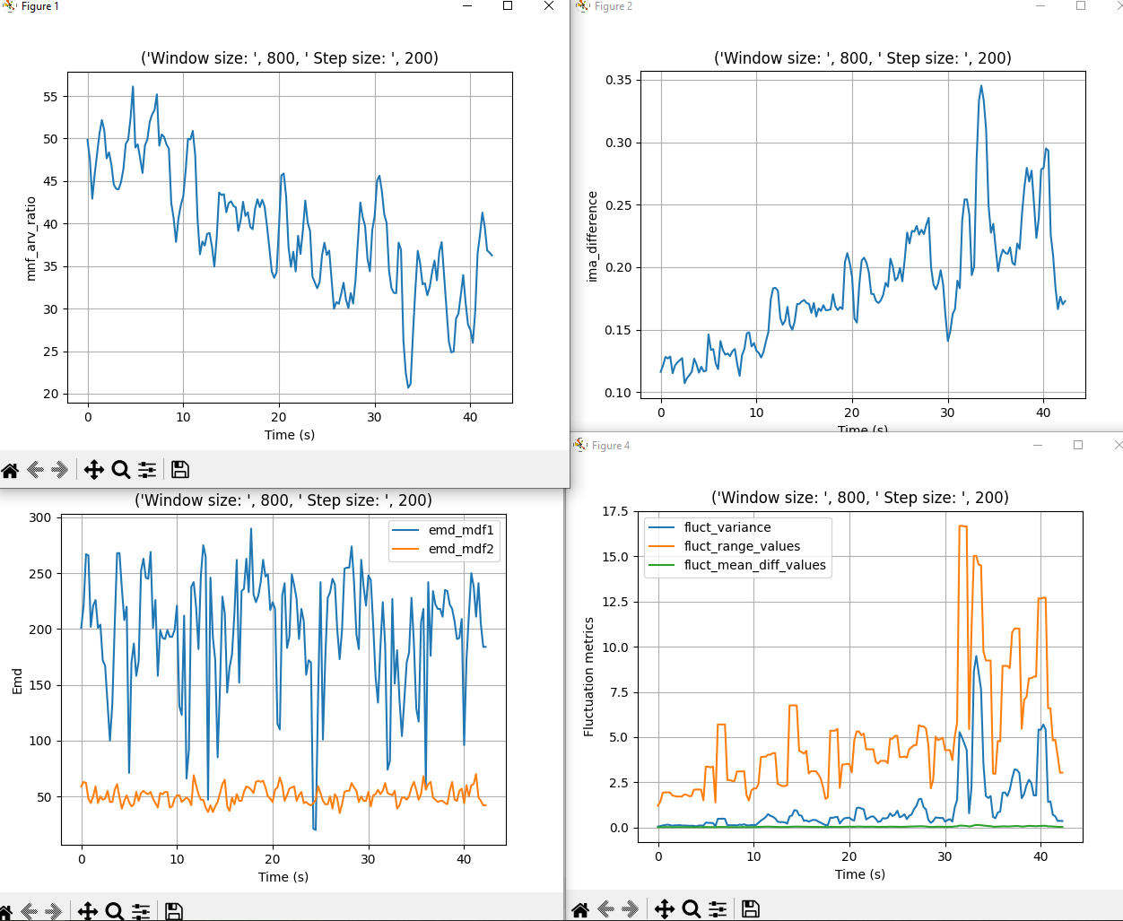

RMS array signal gia mario_ID1 me rms window 80  
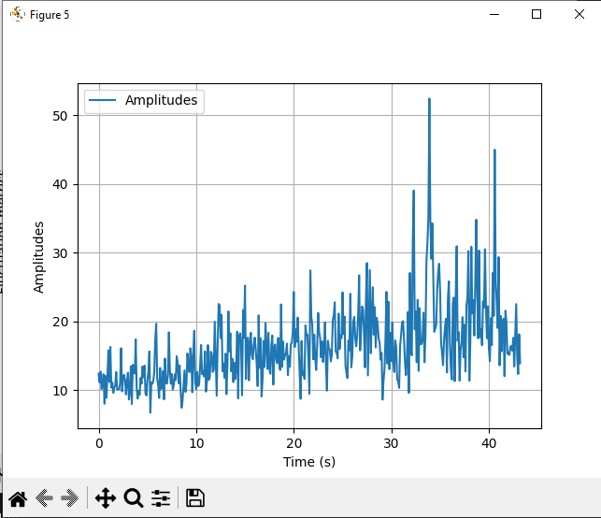

RMS array signal gia next_ID2 me rms window 80

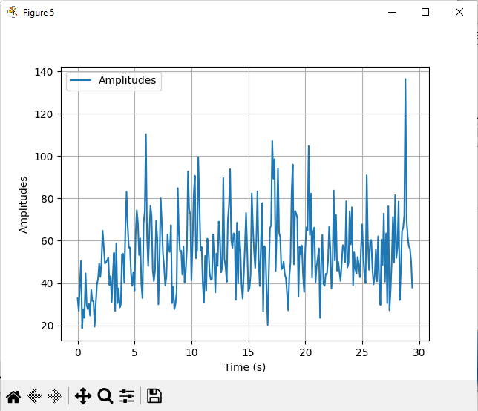

RMS array signal gia next3_ID2 me rms window 80

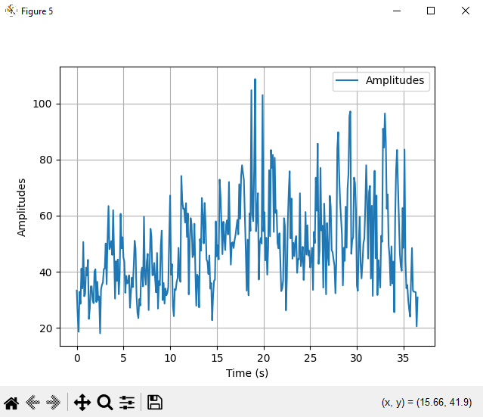

RMS array signal gia alexia_ID2 me rms window 80

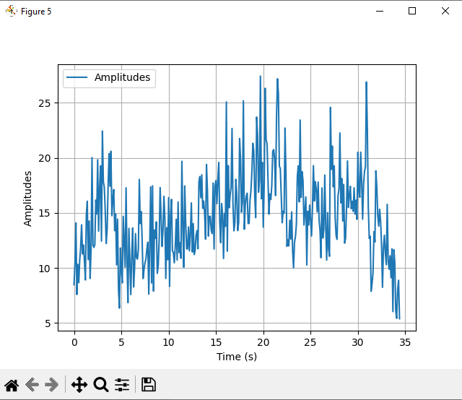

RMS array signal gia marios_ID1 me rms window 400

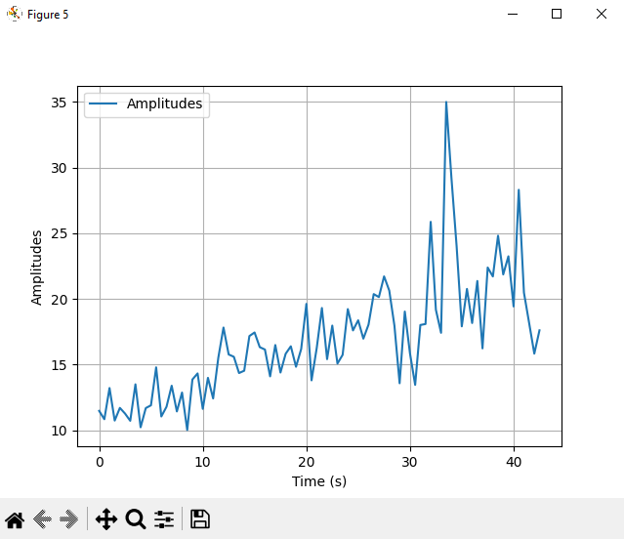

RMS array signal gia alexia_ID1 me rms window 400

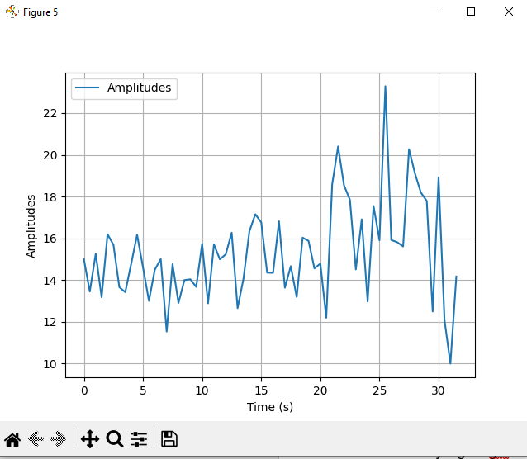

RMS array signal gia nektarios_ID1 me rms window 400

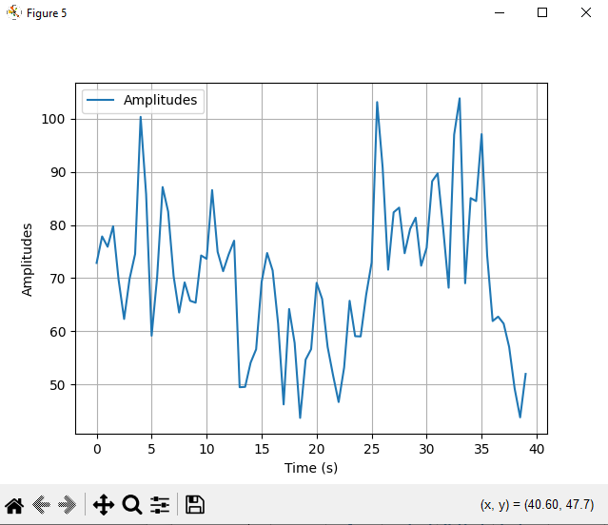

RMS array signal gia vasilis_ID1 me rms window 400

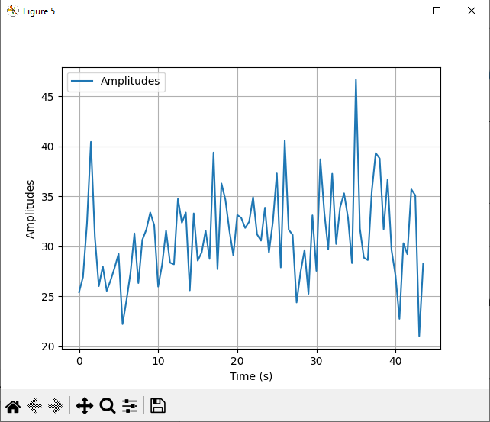

RMS array signal gia next_ID1 me rms window 400

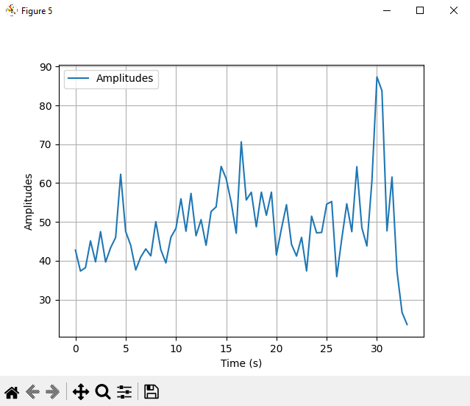

RMS array signal gia next2_ID1 me rms window 400

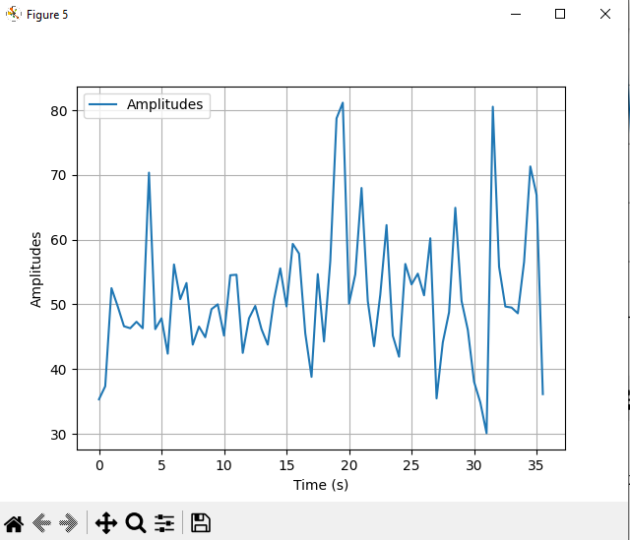

RMS array signal gia next_ID3 me rms window 400

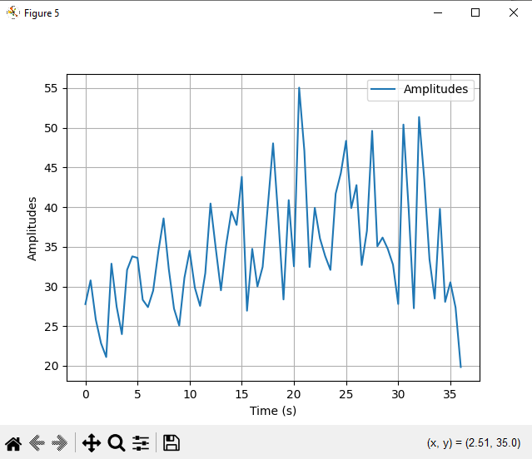



Ongoing